1st October 1931 - This is about protests by unemployed workers in Salford due to the ongoing effects of the Great Depression.

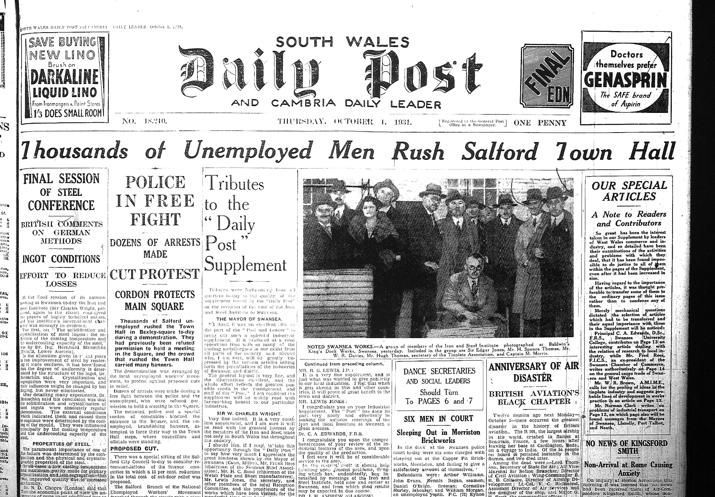

6th October 1931 – This refers to the sudden dissolution of Parliament and the calling of a snap election by Prime Minister Ramsey Macdonald as the Labour government was in crisis over how to react to the Depression. The resulting General Election on October 29th was a landslide for the National coalition mainly consisting of Conservatives.

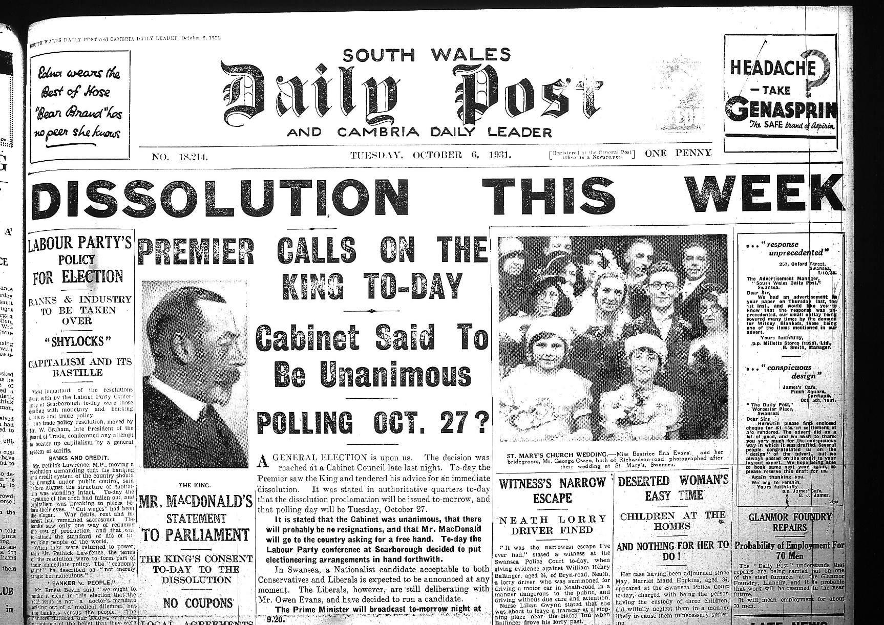
22nd February 1941 - published on the morning after the third night of the Three Night Blitz. It was these raids which destroyed the town centre of Swansea that was familiar to Dylan from his childhood, and which he reminisced about in his broadcast Return Journey.

